* 0000800000001 *


Cambridge IGCSE™

Ma Qingchuan

FIRST LANGUAGE ENGLISH 0500/12
Paper 1 Reading February/March 2025

2 hours
You must answer on the question paper. You will need: Insert (enclosed)

INSTRUCTIONS
- Answer all questions.
- Use a black or dark blue pen.
- Write your name, centre number and candidate number in the boxes at the top of the page.
- Write your answer to each question in the space provided.
- Do not use an erasable pen or correction fluid.
- Do not write on any bar codes.
- If additional space is needed, you should use the lined pages at the end of this booklet; the question number or numbers must be clearly shown.
- Dictionaries are not allowed.

INFORMATION
- The total mark for this paper is 80.
- The number of marks for each question or part question is shown in brackets [ ].
- The insert contains the reading texts.

This document has 16 pages. Any blank pages are indicated.

DC (CE) 341854/3
© UCLES 2025

[Turn over

* 0 6 1 7 4 7 3 9 7 4 *

DO NOT WRITE IN THIS MARGIN
DO NOT WRITE IN THIS MARGIN
DO NOT WRITE IN THIS MARGIN
DO NOT WRITE IN THIS MARGIN
DO NOT WRITE IN THIS MARGIN
* 0000800000002 *
















2

Read Text A, Animals that migrate, in the insert and then answer Questions 1(a)–(e) on this question paper.

Question 1

- Give two examples of animals which migrate (other than humpback whales) according to paragraph 1.

Monarch butterflies and european swallows.✅ 欧洲名称要大写啊！

- Using your own words, explain what the text means by:

‘incredible endurance’ (line 5) The ability to keep travelling for a very long time without giving up.❌ -1

没有解释 incredible，另外 travelling 不是 migration。
参考回答：Exceptional physical stamina to cover vast distances

‘facilitated research’ (line 7) Made scientific studies easier and more effective. ❌ -1

有些画蛇添足，而且添加的不合适，促进研究应该让研究更容易、更有效率，应该用 efficiently
词性也不对，修饰动词要用副词。
参考回答：Made scientific studies easier to carry out

- Reread paragraph 2 (‘Despite … animal movement.’).

Give two ways in which migration differs from other types of animal movement.

Animals return to where they started instead of moving away permanently.It happens at certain times of the year. ✅
虽然答对了，但有些啰嗦，可以回答得简练些，比如：
Migration involves a return journey,and it happens seasonally.

- Reread paragraphs 3 and 4 (‘Astonished … GPS-tagged zebras.’).

- Identify two things scientists had to do before they were able to study how far the plains zebras travelled during migration.
Put satellite-tracking collars on eight female zebras.Sedate the zebras so they became calm before approaching them.✅
按操作顺序说比较好，先麻醉，再放置跟踪器

- Explain what researchers in the second study did to test what might influence the direction in which migrating zebras travelled.

Researchers created two computer models. One assumed zebras travelled by using what they could sense around them, while the other assumed they followed memories from previous migrations. They then Then compared both simulated routes with the real GPS tracks of zebras to see which model was more accurate.✅

© UCLES 2025 0500/12/F/M/25

* 0000800000003 *
















3

- Reread paragraph 5 (‘Preliminary … lead scientist.’).

Using your own words, explain why some people might not accept the findings of the study as conclusive.

Some people may not accept the study because the results are only preliminary and more years of monitoring are needed. In addition, the researchers did not include all possible influences, such as predators, and genetic factors may also affect the zebras' migration.✅

这题出得有意思，问为何有些人不接受研究的结论具有决定性，而这一段落并没有直接写哪些人不同意哪些方面，而是要读者从用词和事实来合理地推断出来。

© UCLES 2025
DO NOT WRITE IN THIS MARGIN
DO NOT WRITE IN THIS MARGIN
DO NOT WRITE IN THIS MARGIN
DO NOT WRITE IN THIS MARGIN
DO NOT WRITE IN THIS MARGIN
0500/12/F/M/25
[Turn over

DO NOT WRITE IN THIS MARGIN
DO NOT WRITE IN THIS MARGIN
DO NOT WRITE IN THIS MARGIN
DO NOT WRITE IN THIS MARGIN
DO NOT WRITE IN THIS MARGIN
* 0000800000004 *
















4

Read Text B, Zozu’s story, in the insert, and answer Question 1(f) on this question paper.

- According to Text B, what are the reasons why changes to animal migrations have occurred and why are these changes worrying?

You must use continuous writing (not note form) and use your own words as far as possible.

Your summary should not be more than 120 words.

Up to 10 marks are available for the content of your answer and up to 5 marks for the quality of your writing.

Changes in migration have happened because rising temperatures have altered normal routes. Some animals now remain in cities because they can easily find food from rubbish dumps instead of travelling long distances. Human development, including roads, housing and other construction, has broken up natural habitats and blocked migration paths. In addition, forests have been cleared, removing places where migrating animals can rest. These changes are worrying because staying in one area allows parasites to spread more easily. They also disrupt ecosystems by reducing insect control, seed distribution and pollination. Birds that no longer migrate may compete with local species for limited resources, while some migratory animals are declining and their journeys are becoming threatened.

Content：9/10
已涵盖的内容：
Forrest原文 | 得分点
Changes in migration have happened because rising temperatures have altered normal routes. | global warming
*很自然的paraphrase，没有直接照抄原文！很棒～
*normal routes建议改成：usual migration routes → normal在语义上不够合适。在动物迁徙里，文章真正想表达的不是这条路线是“正常的”，另一条路线是“不正常的”，而是“动物通常会走的 / 长期以来形成的 / 原本的迁徙路线”
Some animals now remain in cities because they can easily find food from rubbish dumps instead of travelling long distances. | food in landfills distracts them / junk food offers easier feeding option
很棒的逻辑：容易找到食物 → 不再需要长距离迁徙
Human development, including roads, housing and other construction, has broken up natural habitats and blocked migration paths. | urbanisation / expansion of cities / increased infrastructure  +  habitat divided / manmade barriers
Forrest没有很机械地一个评分点写一句，而是把相关信息进行合理地结合到一个句子里，也用上了长难句，真厉害！
In addition, forests have been cleared, removing places where migrating animals can rest. | deforestation / destruction of stopover sites
这里写得非常好：stopover sites → places where migrating animals can rest
之前写article也讲过这种方法，如果不知道一个东西的英文，就尝试用句子解释它“是什么”
现在Forrest举一反三啦
↑ 以上内容为回答“为什么动物迁徙发生变化”↑
These changes are worrying because staying in one area allows parasites to spread more easily. | migration guards against parasites
They also disrupt ecosystems by reducing insect control, seed distribution and pollination. | affects ecosystem (in destination/Africa)
Forrest把“seed dispersal”用了（own words）“seed distribution”，是很棒的改写能力！
Birds that no longer migrate may compete with local species for limited resources | increased competition for resources for resident non-migratory species
while some migratory animals are declining and their journeys are becoming threatened. | some migratory animals are declining → species in decline

未涵盖的点：
attempts to solve it have failed
loss of research
（原文一共11个点，需要涵盖10个，即可拿到content10/10）

Writing：5/5（！！）
Own words用得很好
信息组合+总结能力很好
比较少无关细节（很大的进步）
字数控制非常好（114/120）

© UCLES 2025 0500/12/F/M/25

DO NOT WRITE IN THIS MARGIN
DO NOT WRITE IN THIS MARGIN
DO NOT WRITE IN THIS MARGIN
DO NOT WRITE IN THIS MARGIN
DO NOT WRITE IN THIS MARGIN
* 0000800000006 *
















6

Read Text C, The last migration, in the insert and then answer Questions 2(a)–(d) on this question paper.

Question 2

- Identify a word or phrase from the text which suggests the same idea as the words underlined:

  - The vehicle that Lotta hired was inexpensive.

Cheap ✅
  - Seeing the flashing signals on the computer screen stops Lotta worrying that the trackers will not work.

第一次回答：melts me with relief
第二次修改：blinking red lights ✅

  - Even though there are still a few bird species left alive, there is no longer any money available to pay for scientists to study them.

第一次回答：there's no longer any funding for research
第二次修改：Some birds remain ✅

  - Lotta explains how the migrating birds begin by taking different routes before they rejoin each other to find where the fish are.

merge together ✅

- Using your own words, explain what the writer means by each of the words underlined:

‘I’ve put trackers on three, but couldn’t afford cameras,’ I explain, doggedly following Ennis back to his vessel. ‘They’ll only help to pinpoint where the birds fly. Someone needs to witness how they survive, to learn. Take me south – we’ll follow them. If there are fish left, those birds will find them.’

  - vessel boat,ship ✅

  - pinpoint find the exact location ✅

  - witness see for themselves ✅ （但建议用by，体现自己亲自看到）

© UCLES 2025 0500/12/F/M/25

* 0000800000007 *
















7

- Use one example from the text below to explain how the writer suggests Lotta’s attitude to the project.

Use your own words in your explanation.

I’m not sure when dreaming of this last desperate project began, but it’s part of me now as much as the instinct for breath. It swallowed me whole – a fantasy quest, securing a place on a fishing vessel and having its captain carry me far south following the longest natural migration of any living creature.

The phrase "it swallowed me whole" suggests that the project has taken over Lotta's life. She is completely absorbed in it and is willing to devote all her time and effort to discovering the birds' migration.

3/3 → 有合适的例子 (1’) + comprehensive explanation (1’)，充分解释作者怎样表现Lotta对项目的态度 (1’)

点评：
Forrest原文 | 得分点
例子选取：it swallowed me whole | It swallowed me whole – a fantasy quest
swallowed me whole 是一个非常强的比喻，它不是简单说：“I am interested in the project.”
态度：deeply absorbed / consumed / obsessed / driven

has taken over Lotta’s life | completely consumed by the idea  took over her thoughts
Forrest解释了这个比喻背后的意思: has taken over Lotta’s life
但是这句分析不是特别严谨。
因为swallowed me whole强调: 她整个人被这个想法吞没、占据
所以更贴切的说法是“the project has completely taken over her thoughts and attention”

*completely absorbed in it  *and is willing to devote all her time and effort to *discovering the birds’ migration. | completely consumed by the idea
all her time and effort → 有点绝对
原文有表现出她极度投入，但没有明确说“她把‘所有’时间都花在项目上”
想要更加严谨，可以改成：she is willing to devote enormous time and effort to the project

DO NOT WRITE IN THIS MARGIN
DO NOT WRITE IN THIS MARGIN
DO NOT WRITE IN THIS MARGIN
DO NOT WRITE IN THIS MARGIN
DO NOT WRITE IN THIS MARGIN
© UCLES 2025

0500/12/F/M/25

[Turn over

DO NOT WRITE IN THIS MARGIN
DO NOT WRITE IN THIS MARGIN
DO NOT WRITE IN THIS MARGIN
DO NOT WRITE IN THIS MARGIN
DO NOT WRITE IN THIS MARGIN
* 0000800000008 *
















8

- Reread paragraphs 1 and 13.

- Paragraph 1 begins ‘I’m watching …’ and is about the actions of Lotta and the bird.
- Paragraph 13 begins ‘Months later …’ and is about what Ennis and Lotta discover when they land at the end of their journey.

Explain how the writer uses language to convey meaning and to create effect in these paragraphs. Choose three examples of words or phrases from each paragraph to support your answer. Your choices should include the use of imagery.

Write about 200 to 300 words.

Up to 15 marks are available for the content of your answer.

这个回答要写在本上，拍照放在这里

In paragraph 1, the writer presents the bird as both vulnerable and determined. The phrase “a small burst of defiance” personifies the bird, suggesting it is courageously resisting Lotta despite its small size. This makes readers admire its spirit and shows that it is a wild creature unwilling to surrender.
The description “Her heartbeat pounds fast and fragile inside my palm” combines sound and touch imagery. The verb “pounds” conveys the bird’s fear and panic, while “fragile” reminds us how easily it could be harmed. This creates tension because Lotta is responsible for protecting such a delicate animal.
Finally, the bird “explodes free, swooping at me suddenly” is a powerful metaphor. The verb “explodes” suggests a sudden release of energy, while “swooping” emphasises its speed and agility. This dramatic image highlights the bird’s strength and freedom once it escapes.
In paragraph 13, the language changes from uncertainty to wonder. The description “hundreds of terns smother an expanse of unspoiled ice” creates a striking visual image. The verb “smother” suggests the birds completely cover the landscape, emphasising how unexpectedly abundant life still is.
The birds are then described as “dipping gracefully, diving hungrily”. The contrasting adverbs show both elegance and determination. Their movements seem effortless, but their hunger reminds readers that survival still depends on finding food.
Finally, the question “What else is hiding in these clean, untouched waters – this sanctuary?” uses both a rhetorical question and the metaphor “sanctuary.” This suggests the place is a safe refuge where nature has survived human destruction. It leaves readers with a sense of hope and wonder that life can still flourish in an unspoiled environment.

13/15
Paragraph 1
1. “a small burst of defiance”→ 一阵短暂而微弱的反抗
*defiance = 反抗、不服从
*burst = 突然短暂的一下
*small = 小的、微弱的
因此，Forrest写“courageously resisting Lotta”（勇敢地反抗Lotta），是原文没提到的，因为原文强调的是这只鸟很小、很脆弱，但它还是本能地反抗了一下。

建议改成：brief but determined resistance
*brief 对应 burst
*resistance 对应 defiance
*determined 表示它在反抗

2. “Her heartbeat pounds fast and fragile inside my palm”→ 很好
得分点：
stress is affecting the bird’s heart rate
sounds delicate as if it might break
emphasises the need for extreme care
bird feels captured / imprisoned

3. “explodes free, swooping at me suddenly”
*“is a powerful metaphor” 这句话没有什么实际分析价值
考试不会考Forrest知不知道这是metaphor，而是考察能不能解释这个词为什么有效
因此，建议写：The verb “explodes” suggests a sudden and forceful release of energy.

*“swooping emphasises its speed and agility” 漏掉了 “at me” （⚠ 很重要的信息 ⚠）
文章原文：swooping at me → 鸟挣脱以后，并没有只是飞走，反而朝 Lotta 俯冲过去（它在反击、报复 Lotta）
和前面的 “a small burst of defiance” 呼应了：这只鸟一直都没有完全屈服!

Paragraph 13
1. “hundreds of terns smother an expanse of unspoiled ice”
得分点：
*release of emotion at the quantity of birds
*completely covering the frozen land
*perfect, pristine ice
*not destroyed by humans

Forrest原文：
completely cover the landscape → 鸟多到把整片景观都覆盖住
unexpectedly abundant life still is → 强调生命数量之多，而且这种丰富是出乎意料的

建议加入分析 “smother” 本身给人的感觉
→ 覆盖得严严实实甚至“闷住、窒息”的感觉
→ 让鸟群显得数量惊人，密集到几乎把整片冰面覆盖掉
Forrest原文：the birds completely cover the landscape → 只是在解释smother的基本意思，没有解释writer’s effect

这道题最大的问题：
Forrest已经可以识别metaphor，personification，imagery，rhetorical question等等；但是修辞名称本身几乎不值分。比如“This is a powerful metaphor.”其实信息量很低。Forrest真正要做的是思考：为什么这个具体的词特别有效？它让我们看到、听到、感觉到什么？它有哪些额外联想？
每次答题都可以问问；What does it literally suggest? → What does it make me imagine? → What does that reveal/create here?

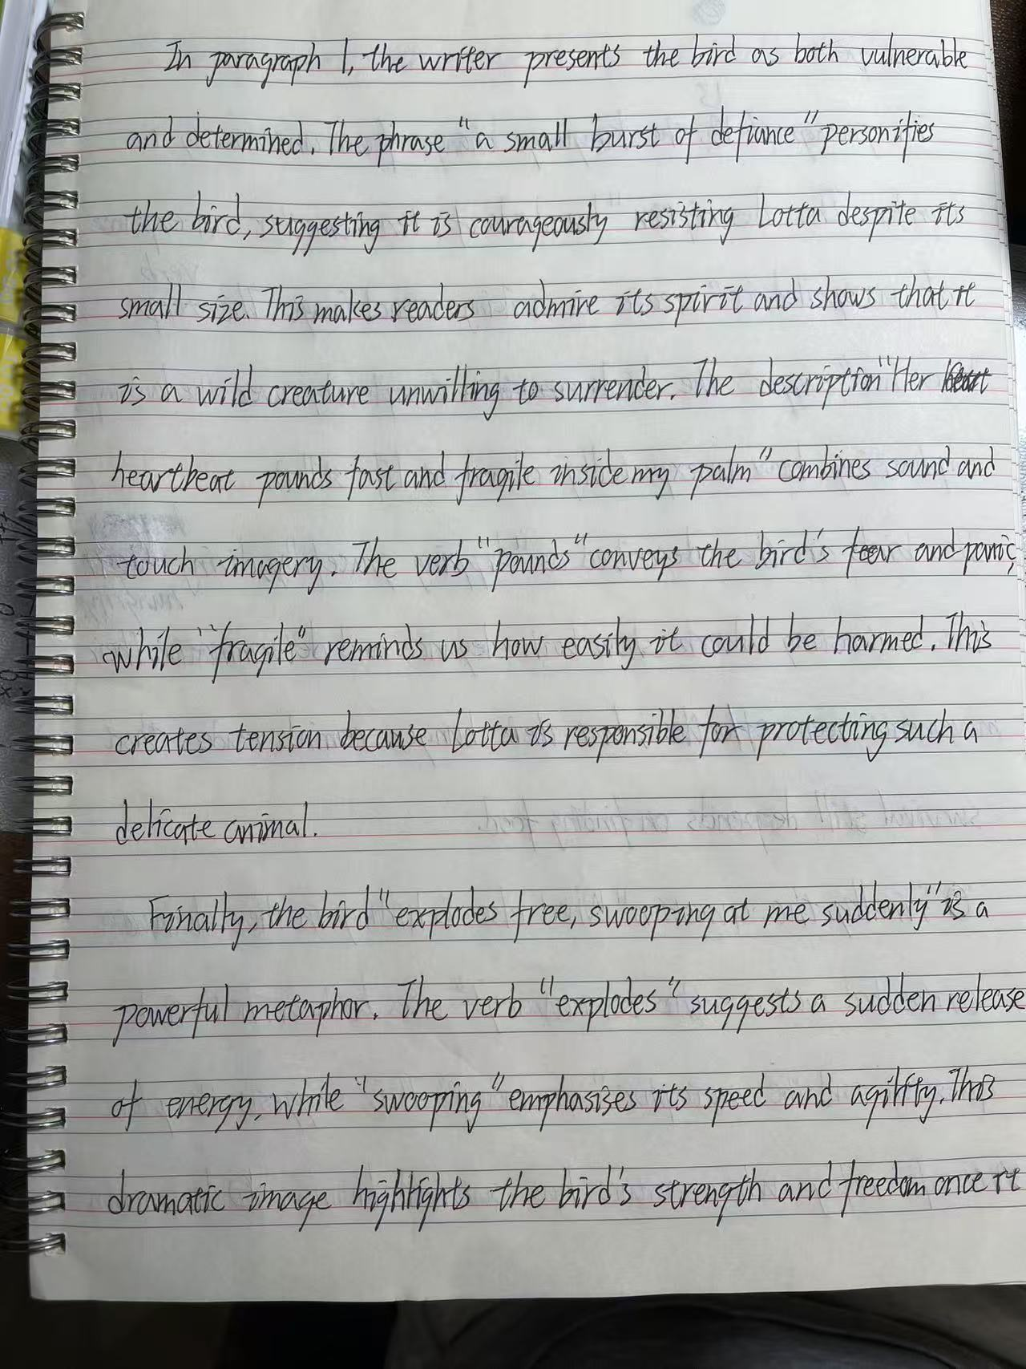
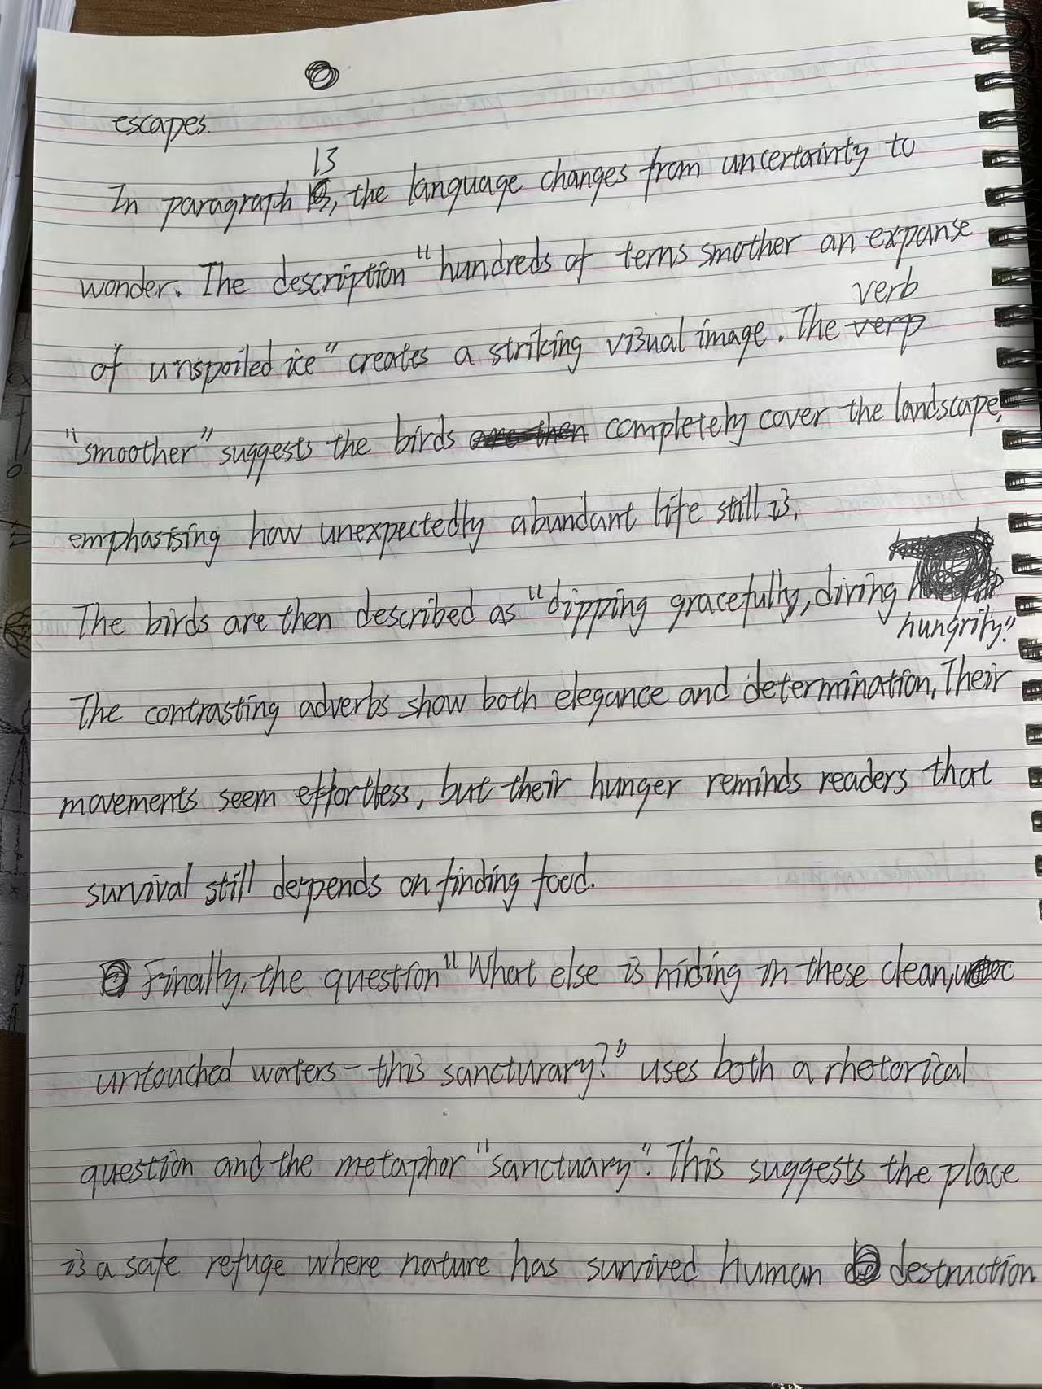

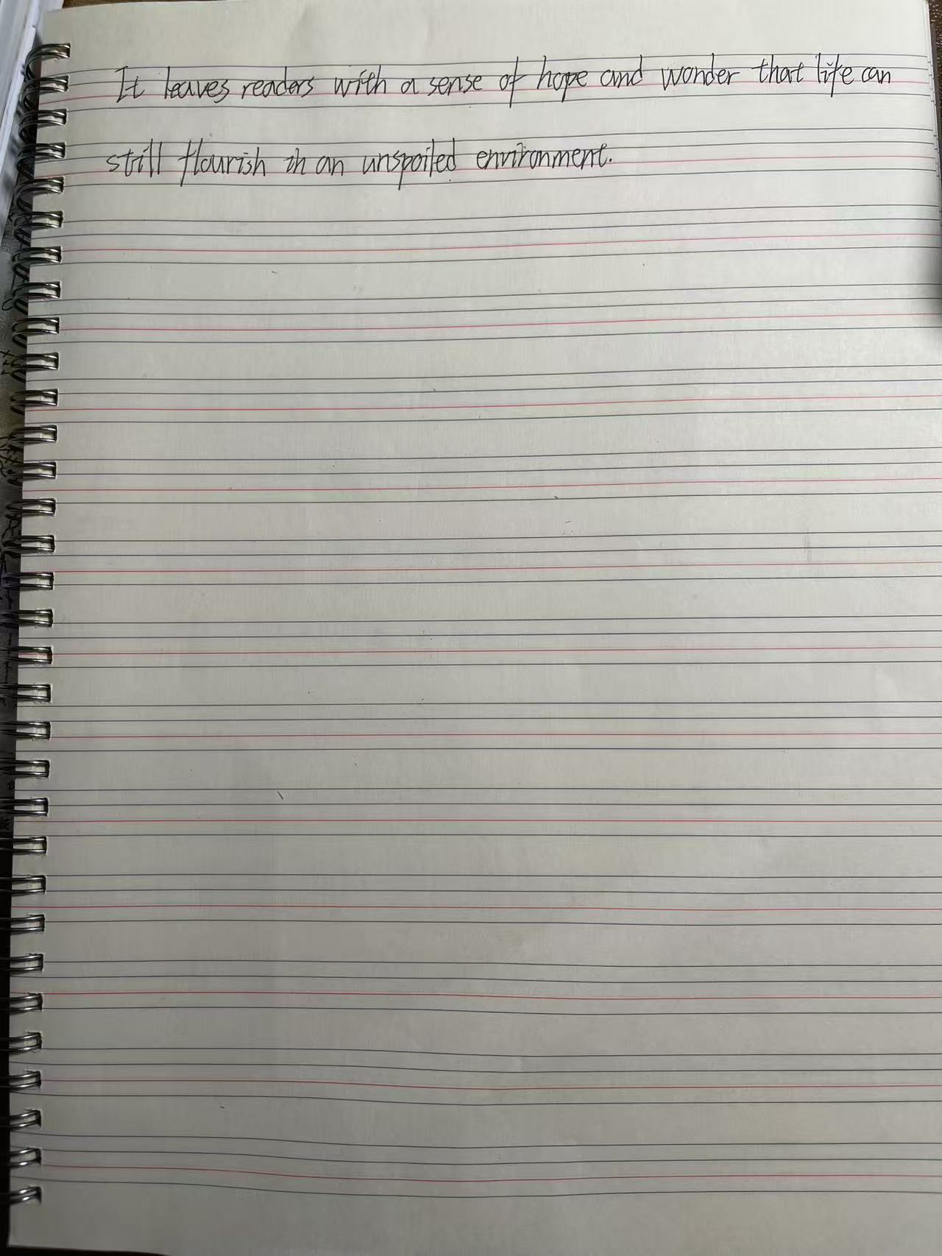

25 0500/12/F/M/25

* 0000800000009 *
















9

...................................................................................................................................................

...................................................................................................................................................

...................................................................................................................................................

...................................................................................................................................................

...................................................................................................................................................

...................................................................................................................................................

...................................................................................................................................................

...................................................................................................................................................

...................................................................................................................................................

...................................................................................................................................................

...................................................................................................................................................

...................................................................................................................................................

...................................................................................................................................................

...................................................................................................................................................

...................................................................................................................................................

...................................................................................................................................................

...................................................................................................................................................

...................................................................................................................................................

...................................................................................................................................................

...................................................................................................................................................

...................................................................................................................................................

...................................................................................................................................................

...................................................................................................................................................

...................................................................................................................................................

...................................................................................................................................................

...................................................................................................................................................

. [15]

DO NOT WRITE IN THIS MARGIN
DO NOT WRITE IN THIS MARGIN
DO NOT WRITE IN THIS MARGIN
DO NOT WRITE IN THIS MARGIN
DO NOT WRITE IN THIS MARGIN

© UCLES 2025

0500/12/F/M/25
[Total: 25] [Turn over

DO NOT WRITE IN THIS MARGIN
DO NOT WRITE IN THIS MARGIN
DO NOT WRITE IN THIS MARGIN
DO NOT WRITE IN THIS MARGIN
DO NOT WRITE IN THIS MARGIN
* 0000800000010 *
















10

Reread Text C, The last migration, in the insert and then answer Question 3 on this question paper. Question 3
You are a journalist. You have interviewed Ennis and Lotta months after they have returned from their trip. You write a magazine article about Lotta’s research project and the conservation work they are both now involved in.

In your article, you should:

- describe what Lotta did to prepare for the research project and the challenges Lotta faced
- explain why Lotta needed Ennis’s help with the project and why Ennis decided to help Lotta
- explain how Ennis and Lotta felt about what happened on their journey and the changes they hope to bring about in the future.

Write the words of the article.

Base your article on what you have read in Text C, but be careful to use your own words. Address each of the three bullets.

Write about 250 to 350 words.

Up to 15 marks are available for the content of your answer and up to 10 marks for the quality of your writing.

Question 3 以前练过，现在先不练，重点练习前面的题目！！！
..........................................................................................................................................................

..........................................................................................................................................................

..........................................................................................................................................................

..........................................................................................................................................................

..........................................................................................................................................................

..........................................................................................................................................................

..........................................................................................................................................................

..........................................................................................................................................................

..........................................................................................................................................................

..........................................................................................................................................................

..........................................................................................................................................................

..........................................................................................................................................................

..........................................................................................................................................................

..........................................................................................................................................................

..........................................................................................................................................................

..........................................................................................................................................................

© UCLES 2025 0500/12/F/M/25

DO NOT WRITE IN THIS MARGIN
DO NOT WRITE IN THIS MARGIN
DO NOT WRITE IN THIS MARGIN
DO NOT WRITE IN THIS MARGIN
DO NOT WRITE IN THIS MARGIN
* 0000800000011 *
















11

..........................................................................................................................................................

..........................................................................................................................................................

..........................................................................................................................................................

..........................................................................................................................................................

..........................................................................................................................................................

..........................................................................................................................................................

..........................................................................................................................................................

..........................................................................................................................................................

..........................................................................................................................................................

..........................................................................................................................................................

..........................................................................................................................................................

..........................................................................................................................................................

..........................................................................................................................................................

..........................................................................................................................................................

..........................................................................................................................................................

..........................................................................................................................................................

..........................................................................................................................................................

..........................................................................................................................................................

..........................................................................................................................................................

..........................................................................................................................................................

..........................................................................................................................................................

..........................................................................................................................................................

..........................................................................................................................................................

..........................................................................................................................................................

..........................................................................................................................................................

..........................................................................................................................................................

. [25]

© UCLES 2025 0500/12/F/M/25

DO NOT WRITE IN THIS MARGIN
DO NOT WRITE IN THIS MARGIN
DO NOT WRITE IN THIS MARGIN
DO NOT WRITE IN THIS MARGIN
DO NOT WRITE IN THIS MARGIN
* 0000800000012 *
















12

Additional page

If you use the following page to complete the answer to any question, the question number must be clearly shown.

..................................................................................................................................................................

..................................................................................................................................................................

..................................................................................................................................................................

..................................................................................................................................................................

..................................................................................................................................................................

..................................................................................................................................................................

..................................................................................................................................................................

..................................................................................................................................................................

..................................................................................................................................................................

..................................................................................................................................................................

..................................................................................................................................................................

..................................................................................................................................................................

..................................................................................................................................................................

..................................................................................................................................................................

..................................................................................................................................................................

..................................................................................................................................................................

..................................................................................................................................................................

..................................................................................................................................................................

..................................................................................................................................................................

..................................................................................................................................................................

..................................................................................................................................................................

..................................................................................................................................................................

..................................................................................................................................................................

..................................................................................................................................................................

..................................................................................................................................................................

..................................................................................................................................................................

© UCLES 2025 0500/12/F/M/25

DO NOT WRITE IN THIS MARGIN
DO NOT WRITE IN THIS MARGIN
DO NOT WRITE IN THIS MARGIN
DO NOT WRITE IN THIS MARGIN
DO NOT WRITE IN THIS MARGIN
* 0000800000013 *
















13

Additional page

If you use the following page to complete the answer to any question, the question number must be clearly shown.

..................................................................................................................................................................

..................................................................................................................................................................

..................................................................................................................................................................

..................................................................................................................................................................

..................................................................................................................................................................

..................................................................................................................................................................

..................................................................................................................................................................

..................................................................................................................................................................

..................................................................................................................................................................

..................................................................................................................................................................

..................................................................................................................................................................

..................................................................................................................................................................

..................................................................................................................................................................

..................................................................................................................................................................

..................................................................................................................................................................

..................................................................................................................................................................

..................................................................................................................................................................

..................................................................................................................................................................

..................................................................................................................................................................

..................................................................................................................................................................

..................................................................................................................................................................

..................................................................................................................................................................

..................................................................................................................................................................

..................................................................................................................................................................

..................................................................................................................................................................

..................................................................................................................................................................

© UCLES 2025 0500/12/F/M/25

DO NOT WRITE IN THIS MARGIN
DO NOT WRITE IN THIS MARGIN
DO NOT WRITE IN THIS MARGIN
DO NOT WRITE IN THIS MARGIN
DO NOT WRITE IN THIS MARGIN
* 0000800000014 *
















14

BLANK PAGE

© UCLES 2025 0500/12/F/M/25

DO NOT WRITE IN THIS MARGIN
DO NOT WRITE IN THIS MARGIN
DO NOT WRITE IN THIS MARGIN
DO NOT WRITE IN THIS MARGIN
DO NOT WRITE IN THIS MARGIN
* 0000800000015 *
















15

BLANK PAGE

© UCLES 2025 0500/12/F/M/25

DO NOT WRITE IN THIS MARGIN
DO NOT WRITE IN THIS MARGIN
DO NOT WRITE IN THIS MARGIN
DO NOT WRITE IN THIS MARGIN
DO NOT WRITE IN THIS MARGIN
* 0000800000016 *
















16

BLANK PAGE

Permission to reproduce items where third-party owned material protected by copyright is included has been sought and cleared where possible. Every reasonable effort has been made by the publisher (UCLES) to trace copyright holders, but if any items requiring clearance have unwittingly been included, the publisher will be pleased to make amends at the earliest possible opportunity.

To avoid the issue of disclosure of answer-related information to candidates, all copyright acknowledgements are reproduced online in the Cambridge Assessment International Education Copyright Acknowledgements Booklet. This is produced for each series of examinations and is freely available to download at www.cambridgeinternational.org after the live examination series.

Cambridge Assessment International Education is part of Cambridge Assessment. Cambridge Assessment is the brand name of the University of Cambridge Local Examinations Syndicate (UCLES), which is a department of the University of Cambridge.

© UCLES 2025 0500/12/F/M/25

